My Work Habits – Primary
– Group Assignment

Find someone who…

Can tell an adult when something is not safe (e.g., glass on the ground, water on the floor).
Cheers for their teammates and shows good sportsmanship.
Comes to school every day and on time.

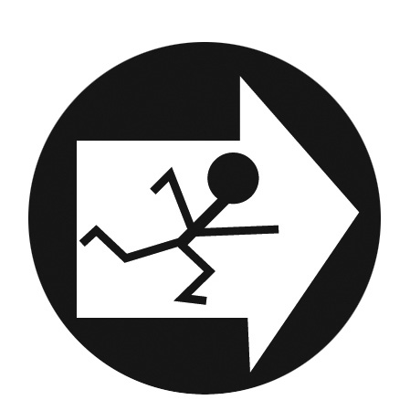

Puts books, pencils and art materials back in the right spot.
Can complete puzzles, crafts and games on their own.
Loves to help their friends
when they need it.

Asks for help when they need it. Can greet a new student or
class visitor with a smile.
Can run a lemonade stand to make money for a charity.

